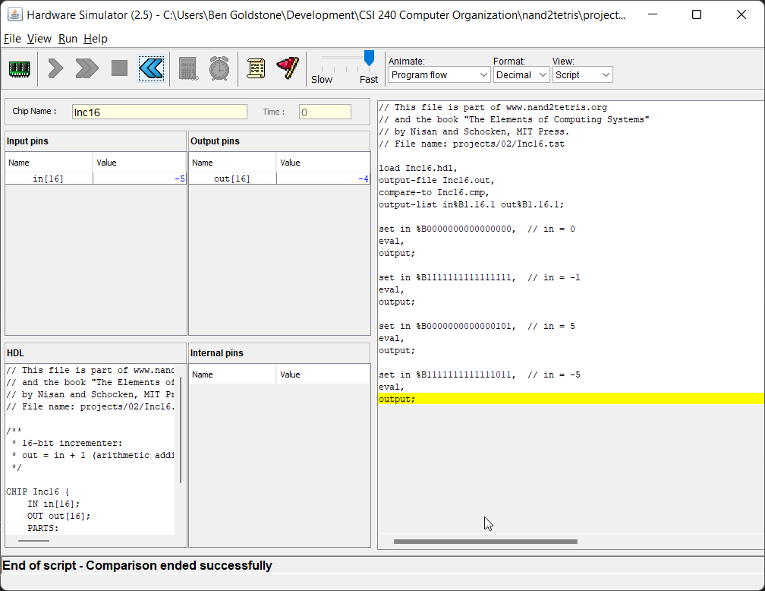

Regular ALU Test

*Nostat ALU Test*